Generate Reports

Document Information

|  |  |
| --- | --- |
| **Document Title** | Title of use case – Verb Noun phrasing is almost always the most appropriate! |
| **Document Owner** |  |
| **Version** |  |
| **Status** |  |
| **Date** |  |

1. Brief Description

This use case allows users to generate reports providing information on the orders, food usage, sales, and other relevant information, suitable for each role (Parent, Student, School Administrator, Food Service Staff).

1. Actors

* Parent
* Student
* School Administrator
* Food Service Staff

1. Trigger

The user wants to generate a report.

1. Pre-Conditions

* The user must be logged into the system.

1. Post-Conditions

* Reports are generated and displayed to the user.

1. Basic Flow
2. The user logs in to the system.
3. User selects the "Reports" section.
4. System displays a list of available report types.
5. User selects the desired report type.
6. System prompts the user to input any necessary parameters.
7. User inputs the necessary parameters.
8. User select “View report” button.
9. System generates the report based on the selected report type and parameters.
10. System displays the generated report to the user.
11. User has the option to save or print the report.
12. Alternate Flows
13. Exception Flows
14. Business Rules

* User can only generate reports for data they have access to based on their role permissions. The reports for each role will be discussed.
* Reports can only be generated for data within a specified time frame.
* User can filter the generated reports data.

1. Non-Functional Requirements

* The system should process the report quickly (1-2s).

1. Supplemental Requirements
2. Visual Model

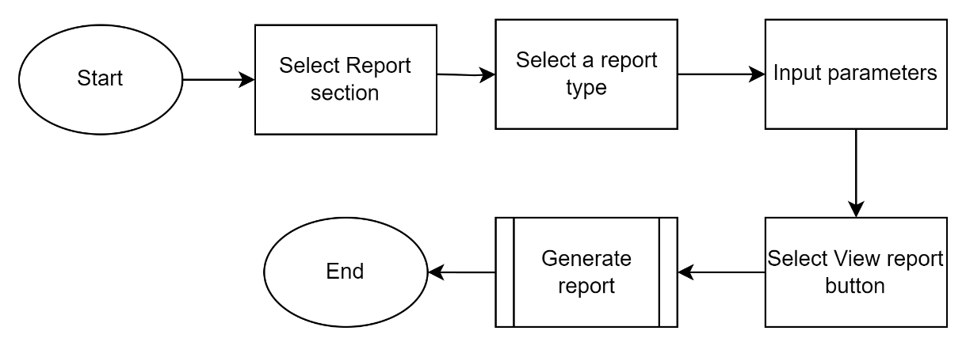

Revision History

|  |  |  |  |  |
| --- | --- | --- | --- | --- |
| V. | Date | Author | Description | Status |
|  |  |  |  |  |
|  |  |  |  |  |